Hist 704
Global Environmental and Climate History

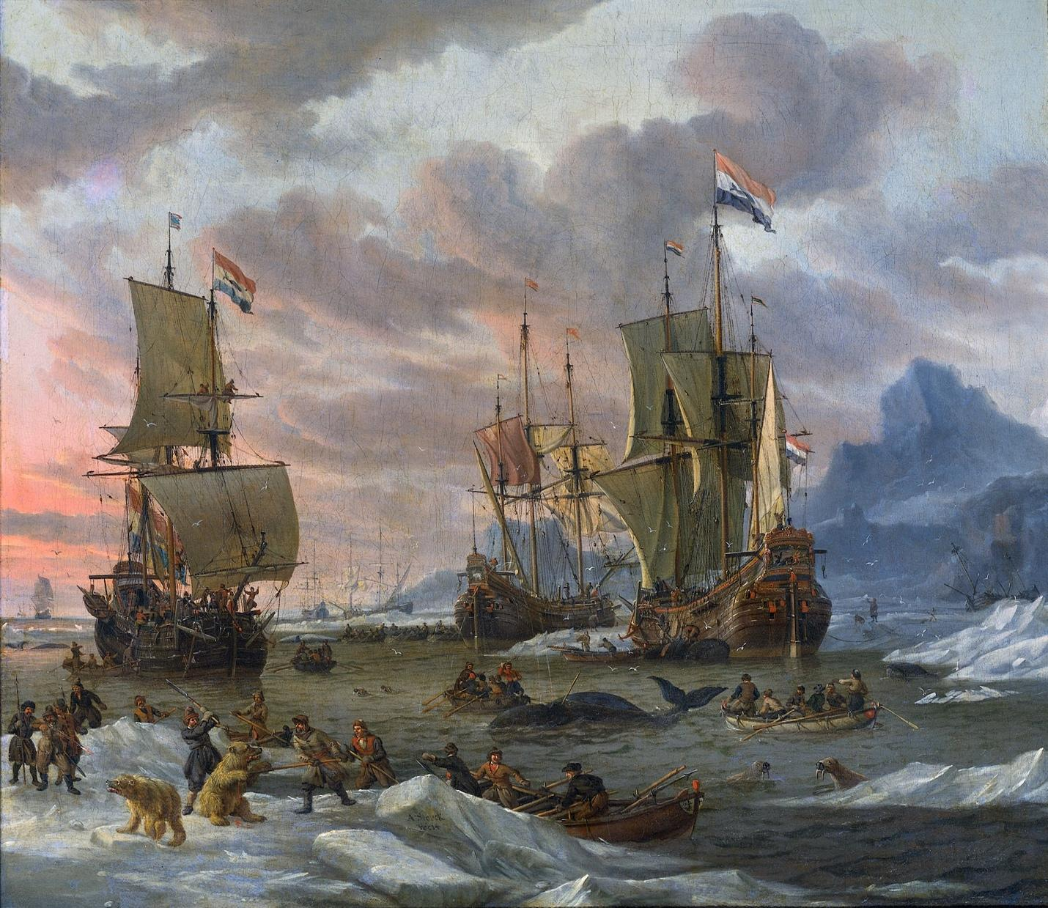

Class Time and Location: Wednesday, 2:00-4:30 PM EST, REYN-130.
Professor McNeill Contact Information: mcneillj@georgetown.edu.
Professor Degroot Contact Information: dd865@georgetown.edu. Web: DagomarDegroot.com.
Professor McNeill Office Hours: Wednesdays, 4:30-6:00 PM, and by appointment.
Professor Degroot Office Hours: Tuesdays, 3:30-4:45 PM, and by appointment.

Course Description:

This course is designed for PhD and MAGIC students with no prior experience in environmental or climate history. It will introduce students to the issues, concerns, debates, and methods of environmental history and one of its liveliest component fields, climate history. The course will be global in scope, with attention to multiple geographic regions, and primarily focused on the last 500 years. It will give special attention to the role of empires in environmental changes and the role of environmental conditions and changes in imperial histories.

Course Goals:

Like other courses offered by the Department of History, this course will help you:

- Gain a deeper appreciation of the nature and practice of history as a discipline, and as the study, based on diverse forms of evidence, of human experiences, interactions, and relationships as they change over time.
- Further hone reading, writing, and oral communication skills.
- Develop your capacity to think historically: to situate events and developments in their historical context for the purpose of critical analysis.
- Expand your ability to engage with complex causal analysis, and to articulate arguments that integrate supporting evidence and analytical commentary.
- View the world from perspectives other than your own.

This course in particular will also:

- Provide you with grounding in two allied subfields within history, and with some approaches to interdisciplinary work.
- Help you understand the deep roots of today’s environmental crises.

Breakdown:

Week-to-week Participation: 30%
Your Discussion Week: 20%
Project Proposal (DUE MARCH 15): 10%
Semester Project (DUE MAY 7): 40%

Evaluation:

Participation:

Every week, we will evaluate your participation on a ten-point scale. You receive five points just for showing up, but if you want more points you’ll have to earn it by speaking. We recommend your draft notes to guide your contributions to our class.

Your Discussion Week:

You will join another student to plan one of our class discussions, on a topic of your choice – but possibly not your first choice. Together, you will write two double-spaced pages on the week’s readings, and then you’ll give a five- to ten-minute presentation based on your two-page paper. You will then ask questions to your fellow students, perhaps including questions you didn’t address in your paper, and you will be graded on both your presentation and paper.

River history
Urban environmental history
Agriculture and pastoralism + Plantations
Capitalocene/anthropocene
Climate and literature
Capitalism and colonialism + (Late Victorian Holocausts?) + Expertise
War and violence
AI
Climate and migration + Climate vulnerability/trauma

Feel free to combine all of these topics in environmental history. You may, for instance, decide to focus on migration through woodlands and grasslands in central Africa during the Medieval Climatic Anomaly - if you can find publications to sustain a good conversation. Feel free to mix and match, with our guidance.

Semester Project:

You will plan a semester project and write a two-page, double-spaced proposal that you’ll submit to your professors. Based on our feedback, you will then draft your project. Your project can take whatever format you find most interesting and useful. If you choose to write a traditional essay, it should be about 20 double-spaced pages long (or approximately 6,000-8,000 words).

Formatting your Essays:

Make a title page! Your title page should have your title in a large, centered font. Your name, the name of this course, your professors’ names, and the date should be in a smaller font at the bottom right of your title page.
Your papers should be written in size 12, Times New Roman font. They should be double-spaced. You should use standard margins (one inch on all sides of the document). Number your pages (at top right).
Use formal academic writing (no contractions or colloquialisms), with topic sentences and reasonably-sized paragraphs (they should not go over a page). In most cases, paraphrase rather than quote from secondary sources.
Cite all sources using Chicago Style formatting, which means that you need footnotes and a bibliography (note that the bibliography does not add to your page count). Click here to find out how you do this. You should always cite at the end of a quotation. Otherwise, include all citations in a footnote at the end of a paragraph. You do not need to cite every sentence. Your footnotes should be numbered sequentially and they should be single-spaced.
Housekeeping:

Course Resources:

There are two resources you should familiarize yourself with in this course. The first is this syllabus. Before asking us a question about the course, please consult the syllabus.
The second resource is our Canvas page. On the page, you’ll be able to submit your assignments and download any readings you can’t access through our library resources. You’ll find assignment instructions, an updated version of our syllabus, and you’ll be able to access our virtual office hours.

House Rules:

You may use whatever device you prefer, as long as it doesn’t distract you from class.

Submitting Assignments:

Assignments should be submitted on Canvas, and all are due at any time on the due date. Every day late will cost you a third of a letter grade (so, for example, an A assignment will receive an A- if it’s a day late).

Extensions:

You may ask us for a short extension before an assignment is due. We will likely grant your request if you A) give us a convincing explanation for why you’re late; B) give us a roadmap that outlines how you will complete your assignment; and C) propose a new due date.

We will only grant requests for an extension on or after the assignment due date in exceptional circumstances (a serious illness, for example). Obviously, if you fail to hand in an assignment, you will receive a zero for that assignment.

Missing Class:

If you think that you will need to miss a class for significant and predictable reasons (such as religious observances), you must inform us of the specific circumstances and dates at the start of term.

You receive a grade for every class you attend (see above). If you do not attend a class, you will receive a grade of zero for the class you missed.

Academic Honesty:

Plagiarism is not just about copying someone else’s writing. Any time you present ideas without correctly citing them, you are committing plagiarism. This is the most serious intellectual offense you can commit at a university, so your professors – us included – take it very seriously.

It is your responsibility to familiarize yourself with the Georgetown University Undergraduate Honor System. It is your professors’ duty to refer academic misconduct – including plagiarism – to the Georgetown Honor Council. If the Council decides that you have plagiarized on an assignment, you will fail that assignment – and you may fail the course.

Beyond the Course:

We are committed to supporting survivors of sexual misconduct, which includes relationship violence, sexual harassment and sexual assault. However, university policy requires faculty to report any disclosures about sexual misconduct to the Georgetown Title IX Coordinator, who directs the University’s response to sexual misconduct.

Georgetown has a number of fully confidential professionals who provide support and assistance to survivors of sexual assault and other forms of sexual misconduct. To connect with those professionals – including to report an incident – and to review our university policies, you can visit: https://sexualassault.georgetown.edu.

Schedule:

Four Weeks Organized by Professors:

January 18

Introductions

Choosing topics for student-led weeks (professors have supplied topics, but students can nominate their own). Students will vote on which topics appear on the syllabus for the weeks after February 8.

January 25

Crosby, Ecological Imperialism.

February 1

Worster, Dust Bowl.

February 8

Degroot, Dagomar, Kevin J. Anchukaitis, Jessica E. Tierney, Felix Riede, Andrea Manica, Emma Moesswilde, and Nicolas Gauthier. “The history of climate and society: a review of the influence of climate change on the human past.” Environmental Research Letters (2022).

White, Sam, Qing Pei, Katrin Kleemann, Lukáš Dolák, Heli Huhtamaa, and Chantal Camenisch. “New perspectives on historical climatology.” Wiley Interdisciplinary Reviews: Climate Change (2022).

Degroot, Dagomar, Kevin Anchukaitis, Martin Bauch, Jakob Burnham, Fred Carnegy, Jianxin Cui, Kathryn de Luna et al. “Towards a rigorous understanding of societal responses to climate change.” Nature (2021).

Nash, David J., George CD Adamson, Linden Ashcroft, Martin Bauch, Chantal Camenisch, Dagomar Degroot, Joelle Gergis et al. “Climate indices in historical climate reconstructions: a global state of the art.” Climate of the Past (2021).

Nine Weeks Organized by Teams of Two Students:

February 15 River history

Discussion leader(s): Melanie Smith

Readings:

- Husain, Faisal H. Rivers of the Sultan: The Tigris and Euphrates in the Ottoman Empire. Oxford University Press, 2021. Pages 1-20, 59-126, and 145-150.
- Morris, Christopher. The big muddy: An environmental history of the Mississippi and its peoples, from Hernando de Soto to hurricane Katrina. Oxford University Press, 2012. Pages 1-93.
- Zhang, Ling. The river, the plain, and the state: An environmental Drama in northern Song China, 1048–1128. Cambridge University Press, 2016. Pages 23-82 and 172-187.

February 22 Urban EH

Discussion leader(s): Josephine Kim

Readings:

- Haumann, Sebastian, Martin Knoll, and Detlev Mares, eds. Concepts of Urban-Environmental History. Transcript Verlag, 2020. Skip pages 221-64 and 275-86.
- Lahtinen, Rauno, and Timo Vuorisalo. “‘It's War and Everyone Can Do As They Please!’: An Environmental History of a Finnish City in Wartime.” Environmental History 9:4 (2004): 679-700.

March 1 Climate, migration, vulnerability, trauma

Discussion leader(s): Ben Greenho and Rachel Singer

Readings:

- Geoffrey Parker, Global Crisis. Chapters 1-4 (pp. 3-109), Chapter 7 (Ottomans, pp. 185-210), Chapter 16 (Japan, pp. 484-506), Chapter 17 (popular resistance, pp. 509-533), Chapters 21-22 (warfare to welfare, Great Divergence, pp. 612-667).

March 15 Climate & literature/culture

Discussion leader(s): Rosie Click and Adam Teece

Readings:

- Markley, Robert. “Summer’s Lease: Shakespeare in the Little Ice Age.” In Early Modern Ecostudies, pp. 131-142. Palgrave Macmillan, New York, 2008.
- Chiari, Sophie. “Climatic issues in early modern England: Shakespeare's views of the sky.” Wiley Interdisciplinary Reviews: Climate Change 10:4 (2019): e578.
- Ray, Sugata. “Hydroaesthetics in the little ice age: Theology, artistic cultures and environmental transformation in early modern Braj, c. 1560–70.” Journal of South Asian Studies 40:1 (2017): 1-23.
- Williamson, Fiona. "The “cultural turn” of climate history: An emerging field for studies of China and East Asia." Wiley Interdisciplinary Reviews: Climate Change 11:3 (2020): e635.

March 22 War & violence

Discussion leader(s): Eric Anderson and Ethan Barkalow

Readings:

- Emmanuel Krieke, Scorched Earth.

March 29 Agriculture (plantations), pastoralism
Discussion leader(s): Keeheon Lee and Lucy Leonard

Readings:

- Morgan, Philip Joseph, Philip J. Morgan, John R. McNeill, and Matthew Mulcahy. Sea and Land: An Environmental History of the Caribbean. Oxford University Press, 2022. Pages TBA.
- Mauldin, Erin Stewart. Unredeemed land: An environmental history of civil war and emancipation in the cotton South. Oxford University Press, USA, 2018. Pages TBA
- Chapter 3, “Colonialism, Rubber, and the Rainforest,” in Ross, Corey. Ecology and Power in the Age of Empire: Europe and the Transformation of the Tropical World. Oxford University Press, 2017.

April 5: EASTER BREAK, NO CLASS

April 12 Capitalism, colonialism, expertise, local/indigenous knowledge

Discussion leader(s): Yurui Hu and Ethan Weisbaum

Readings:

- Bathsheba Demuth, Floating Coast.
- Article by Jason Moore, TBA.

April 19 Capitalocene and Anthropocene

Discussion leader(s): Sareena Dubey

Readings:

- Steffen, Will et al., “The Anthropocene: conceptual and historical perspectives.” Philosophical Transactions of the Royal Society of London A: Mathematical, Physical and Engineering Sciences 369:1938 (2011): 842-867.
- Malm, Andreas, and Alf Hornborg. “The geology of mankind? A critique of the Anthropocene narrative.” The Anthropocene Review 1:1 (2014): 62-69.
- Jason W. Moore, “The Capitalocene, Part I: on the nature and origins of our ecological crisis.” The Journal of peasant studies 44:3 (2017): 594-630.
- Stephen Pyne, The Pyrocene. Pages TBA.

April 26 Artificial Intelligence and EH

Discussion leader(s): Kit Evans

