HIST 304 - The Global Environmental History of the Cold War
Fall 2017

Discussion:
Monday 3:30-6:00 pm
Reynolds 133
Instructor: Robynne Mellor
Office: ICC 614
Office hours: Wednesday 2:00-4:00 pm, or by appointment
Email: rnm29@georgetown.edu
Course website: canvas.georgetown.edu

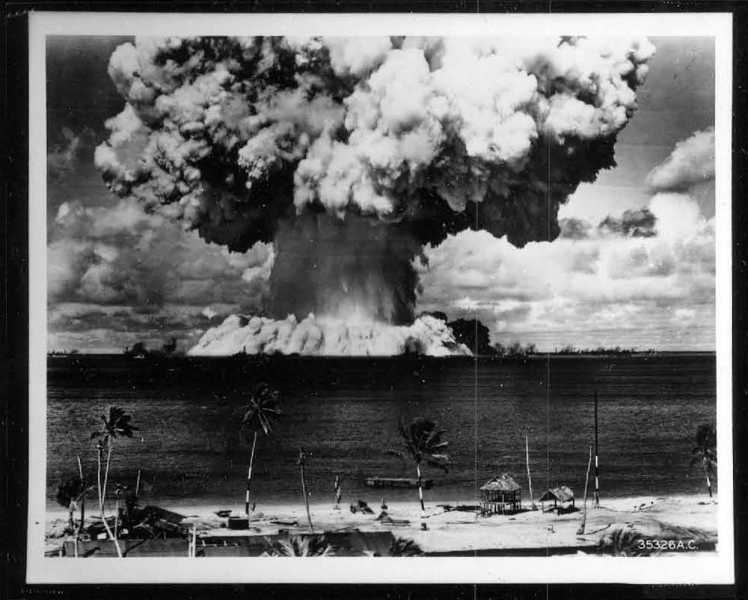
Bikini Island, Baker Explosion, July 25, 1946

The Cold War (1946-89) affected the environment in many ways, both during the conflict and after it. In this course, we will look at how all stages of the nuclear cycle impact the environment, from the mining of uranium from the earth to the deposition of nuclear waste underground. We will consider how nuclear technology contributed to environmental understanding and vice-versa. We will also grapple with the legacy of nuclear technology keeping in mind that the waste produced during the Cold War will be radioactive for tens of thousands of years. Moving away from the atom’s orbit, we will examine the connections between Cold War modernization drives and the environment. As countries fought for influence and stability, they embarked on massive public works projects both at home and abroad such as agricultural programs and dam building, creating far-reaching environmental impacts. Sometimes, Cold War interventions led to war, as was the case in Vietnam, a war deeply intertwined with the Vietnamese landscape. Towards the close of the Vietnam War and with the rise of détente, the world responded with a newfound concern for, and attention to, the environment. We will examine how this shift happened and what it looked like. Finally, we will ponder the balance sheet of how the Cold War affected the environment and the environment affected the Cold War. Was there a difference between socialist and capitalist treatment of nature? Ultimately, we will try to answer the following question: what is the environmental history of the Cold War? How can we comprehend and assess it? Is it a declensionist narrative, or did something good come out of it after all?

To try to fathom the connections between the Cold War and the environment, the class will quantify the ongoing legacy of some portion of the Cold War with an interactive, group-mapping project.

The goals of this course are:
- To help students develop a thorough understanding of environmental history and its main questions and how they relate to the global Cold War
- To help students develop skills in historical inquiry, research, analysis, argumentation, and both written and oral communication
- To help students connect the past with the present, engage with the effects of history, ask big questions about history, and think about ways to answer these questions

Requirements and Grading
We will meet once per week for two and one-half hours. By 10:00 AM on the day of class, each student will post a short (100-200 word) response to the week’s sources on the course blog, including a suggested discussion question as well as questions about anything they do not understand. Students will be encouraged to identify and articulate the holes in their knowledge. We will use these questions (and others from the instructor) to guide our class discussions. We will also analyze primary sources – texts and film. Occasionally, short lectures from the instructor will provide further context. All readings and discussions are relevant for the assigned papers.

The requirements are as follows:
- Attendance, participation, and reading responses: We will meet once per week for two and one-half hours. By 10:00 AM on the day of class, each student will post a short (100-200 word) reading response on the course blog, including a suggested discussion question as well as questions about anything they do not understand. Students will be encouraged to identify and articulate the holes in their knowledge. We will use these questions (and others from the instructor) to guide our class discussions. We will also analyze primary sources – texts and film. Occasionally, short lectures from the instructor will provide further context. Attendance will be taken at each class. Grade will be based on the level of engagement with the sources during the discussion.

- Short Papers: Students will write two short papers using the sources read in class to answer a question that I will give them. There will be three questions, from which the students will choose one to answer. The thesis of the paper will address and answer the question using only the sources used in class. Each question will address a different theme covered. Students need not use all sources read in class, but must draw from at least two different weeks. We will discuss the essay questions in-class before they are assigned.

- Final paper and map: Students will choose a topic for their final projects. These projects will include choosing one aspect of the Cold War’s effects on the environment, quantifying it to the best of the student’s ability with available sources, and mapping it on a digital map to which the entire class will contribute. There will be an in-class discussion of topics so that all students choose a different aspect. Students will write a research paper on their chosen aspect of the environmental impact of the Cold War and map the results of what they found onto the communal map.
Student grades will be calculated on the basis of the following formula:

- 30% Class participation (includes attendance and blog posts)
- 20% Short Paper 1 (6-7 pages)
- 20% Short paper 2 (6-7 pages)
- 30% Mapping project and associated research paper (15 pages)
Sources

Class material will consist of primary and secondary written sources, films, music, and images. I will make all readings aside from the listed books available online through Canvas. Other media is available on the Internet, either through Lauinger Library or other websites to which students have free access. It is recommended that students purchase the following books because we will use them heavily:

Brown, Kate. Plutopia: Nuclear Families, Atomic Cities, and the Great Soviet and American Plutonium Disasters. New York: Oxford University Press, 2013.
Hamblin, Jacob Darwin. Arming Mother Nature: The Birth of Catastrophic Environmentalism. New York: Oxford University Press, 2013.
McNeill, J.R. and Corinna R. Unger, eds. Environmental Histories of the Cold War. New York: Cambridge University Press, 2010.

These books will be available for purchase at the Georgetown bookstore and can also be accessed as course reserves through Lauinger Library. You may also buy digital copies of the first two books, which are cheaper, and there are cheap used copies of Arming Mother Nature available online.

Class Schedule

August 30: Introduction

September 4: Holiday – No Class

Part I: Nuclear Technology and the Environment

September 11: Front End of the Nuclear Cycle: Mining and Milling
Primary:
- Oral interview with Utah miner
- CIA Information Report, “Uranium Ore Mining in the Jachymov Area,” 6 May 1955
Secondary
- Eric Mogren, “Mining the Atom” and Robynne Mellor, “A Comparative Case Study of Uranium Mine and Mill Tailings Regulation in Canada and the United States” in Mining North America, eds. McNeill and Vrtis
- Selections from Exposure: Victims of Radiation Speak Out

September 18: Fuel Production
Primary
- Kathleen Flenniken, “To Carolyn’s Father”
- Selections from oral interview (Jack Rhoades)
- “The city that is not on the map yet [Ozersk]”
- Mayak promotional films
Secondary
- Selections from Kate Brown: Plutopia: Nuclear Families, Atomic Cities, and the Great Soviet and American Plutonium Disasters

September 25: Weapons Testing
Primary
- US - Operation Crossroads (1946) – Baker
- US - Operation Sandstone (1948)
- USSR - RDS-1 (1949)
- UK – Operation Hurricane (1952)
- US - Castle Bravo (1954)
- USSR - RDS-37 (1955)
- UK - Operation Grapple (1957)
- Dave Phillips, “Troops Who Cleaned Up Radioactive Islands Can’t Get Medical Care” New York Times, January 26, 2017
- Kathy Jetnil-Kijiner, “History Project”
Secondary
- Magdalena E. Stawkowski, “’I am a radioactive mutant’: Emergent Biological Subjectivities at Kazakhstan’s Semipalatinsk Test Site”
- Mark D. Merlin and Ricardo M. Gonzalez, “Nuclear Testing in Remote Oceania, 1946-1996,” in McNeill and Unger, Environmental Histories of the Cold War
- Toshihiro Higuchi, “Atmospheric Nuclear Weapons Testing and the Debate on Risk Knowledge” in McNeill and Unger, Environmental Histories of the Cold War
- Advisory Committee on Human Radiation Experiments: "Chapter 11: What We Know"

October 2: The Peaceful Atom
Primary
- Footage of Soviet nuclear test at Chagan, Kazakhstan
- Atomic Energy Commission “Plowshare” video
- “Chinese Communist Party Central Committee Circular concerning the Transfer of Cadres and Workers to Participate in Atomic Energy Development Work (Excerpt)”
- From the Journal of Gromyko, Record of a Conversation with Ambassador Ri Sin-Pal of the Democratic People’s Republic of Korea
Secondary
- Hamblin, Arming Mother Nature: The Birth of Catastrophic Environmentalism, Part I
- Selections from Angela N.H. Creager, Life Atomic: A History of Radioisotopes in Science and Medicine

October 9: Holiday – No Class

October 10 – First Paper Due

Part II: Cold War, Modernization, and the Environment

October 16: The Green Revolution
Primary
- Cultivation of the Virgin Lands (1954) and Ivan Brovkin in the Virgin Lands (1958)
- Report from Deputy Chairman of the State Committee I. Arkhipov to USSR Deputy Minister of Foreign Affairs Cde. G.M. Pushkin (on North Korean agriculture)
- Clip from Michurin (1947)
- This is IRRI (1963)
- IRRI: Rice is Life in Asia
Secondary
- J.R. McNeill, “The Biosphere and the Cold War,” to “Cold War Transport and the Environment”, Cambridge History of the Cold War
- Nick Cullather, “Miracles of Modernization: The Green Revolution and the Apotheosis of Technology”
- Selections from Shapiro, Judith. Mao’s War Against Nature: Politics and the Environment in Revolutionary China

October 23: Pesticides, Chemicals, and Proxy Wars
Primary:
- Film of US soldiers spraying Agent Orange
- Veterans’ Diseases Associated with Agent Orange
Secondary
- “The Dark Shadow of Agent Orange” (in class)
- Apocalypse Now Napalm Scene
- Clip: Vietnam Declares Independence from PBS documentary The Vietnam War
- Selections from David Zierler, Invention of Ecocide: Agent Orange, Vietnam, and the Scientists Who Changed the Way We Think About the Environment
- David Biggs, “Managing a Rebel Landscape: Conservation, Pioneers, and the Revolutionary Past in the U Minh Forest, Vietnam.”

October 30: The Dam Cold War
Primary
- Song: Abd al-Halim Hafiz, “The High Dam”
- Aswan Dam archival footage
- Khrushchev and Nasser at Aswan High Dam Ceremony
Secondary
- Richard P. Tucker, “Containing Communism by Impounding Rivers: American Strategic Interests and the Global Spread of High Dams in the Early Cold War,” in McNeill and Unger, Environmental Histories of the Cold War
- Selections from David Pietz, Yellow River: The Problem of Water in Modern China

November 6: The Militarization of Landscapes
Primary
- Environmental Contamination at Pease Air Force Base, NH
- List of Department of Defense Superfund Sites
- Eyes in Outer Space
- Song: “What a Beautiful World (IGY)”
Secondary
- Hamblin, Arming Mother Nature: The Birth of Catastrophic Environmentalism, Part II
- Gretchen Heefner, “’A Fighter Pilot’s Heaven’: Finding Cold War Utility in the North African Desert”

Part III: Nuclear Reactions, Effects, and Responses

November 13: The Fast and Slow Violence of Radioactive Material: Nuclear Accidents & Waste Disposal
Primary
- Gorbachev’s first address on Chernobyl
- Videos: Chernobyl: Nuclear Meltdown/BBC and White Horse
- Department of Energy Legacy Management Website
Secondary
- John Oliver on Nuclear Waste
- Selections from Svetlana Alexievich, Voices from Chernobyl (in class)
- Selections from Nikolai Egorov, et al. The Radiation Legacy of the Soviet Nuclear Complex
- Selections from Hamblin, Poison in the Well: Radioactive Waste in the Oceans at the Dawn of the Nuclear Age
- Phillip R. Pryde and Don J. Bradley, “The Geography of Radioactive Contamination in the Former USSR”
- Selections from Walker. The Road to Yucca Mountain: The Development of Radioactive Waste Policy in the United States

November 17: Second Paper Due

November 20: Protests, Resistance, and the Rise of Environmentalism
Secondary
- Lake Baikal images and video
- Walter Cronkite’s reports on the first Earth Day: 1,14,15
- From Awareness to Action by William D. Ruckelshaus
Secondary
- Greenpeace: From Hippies to Lobbyists (in class)
- Laurent Coumel, “A Failed Environmental Turn? Khrushchev's Thaw and Nature Protection in Soviet Russia”
- Kai Hünemörder, “Environmental Crisis and Soft Politics: Détente and the Global Environment, 1968-1975,” in McNeill and Unger, Environmental Histories of the Cold War

Part IV: Conclusions

November 27: Communism and the Cold War
- Stephen Brain, “The Appeal of Appearing Green: Soviet-American Ideological Competition and Cold War Environmental Diplomacy”
- Paul R. Josephson, “War on Nature as Part of the Cold War: The Strategic and Ideological Roots of Environmental Degradation in the Soviet Union,” in McNeill and Unger, eds., Environmental Histories of the Cold War
- Pietz, Yellow River

December 4: Against a Declensionist Narrative
Primary
- Stephen Mulvey, “Wildlife Defies Chernobyl radiation,” BBC News
- “7 summers later, weeds engulf Fukushima’s abandoned areas”
Secondary
- Lisa Brady, “Life in the DMZ: Turning a Diplomatic Failure into an Environmental Success”
- Hamblin, Arming Mother Nature: The Birth of Catastrophic Environmentalism, conclusion
- Selections from Shawn William Miller, An Environmental History of Latin America
December 18: Final Papers Due

